Taking an Assessment

Tests, quizzes, and exams are types of assessments that instructors may create in Blackboard to test your knowledge, skill level, and understanding of course material.

For tests and quizzes, the instructor usually assigns point values to questions, and when students' answers are submitted for grading, the results are automatically recorded in My Grades. Results might be released immediately or after all students have completed the exam.

There are many types of questions that can be included in a test or quiz. Common question types that are auto-graded include multiple choice, true/false, matching, and fill-in-the-blank. Essay and short answer questions may also be assigned and are answered in the provided text box. The instructor manually grades your answers to these questions.

The assessment icon looks like a sheet of paper with boxes and lines. You can start the assessment by clicking on the title. When you click on the assessment title, you should be prepared to take it.

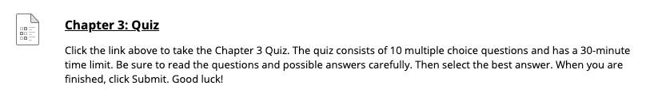

Your instructor typically will communicate the assessment expectations prior to you taking it. You should know the following before you start:
- Is the exam open book?
- How long do I have to complete the exam?
- Can I submit multiple times?

If you do not know the answers to these questions before starting your assessment, ask your instructor.

If you only have one attempt at the assessment, you will only be able to see it once. If you close out of the assessment accidentally or if you lose your Internet connection, no answers will be submitted to your instructor. Therefore, be prepared before starting your exam.

When you are prepared to begin your assessment, click on the title.

Before you click Begin, note the following important information that displays on the screen.
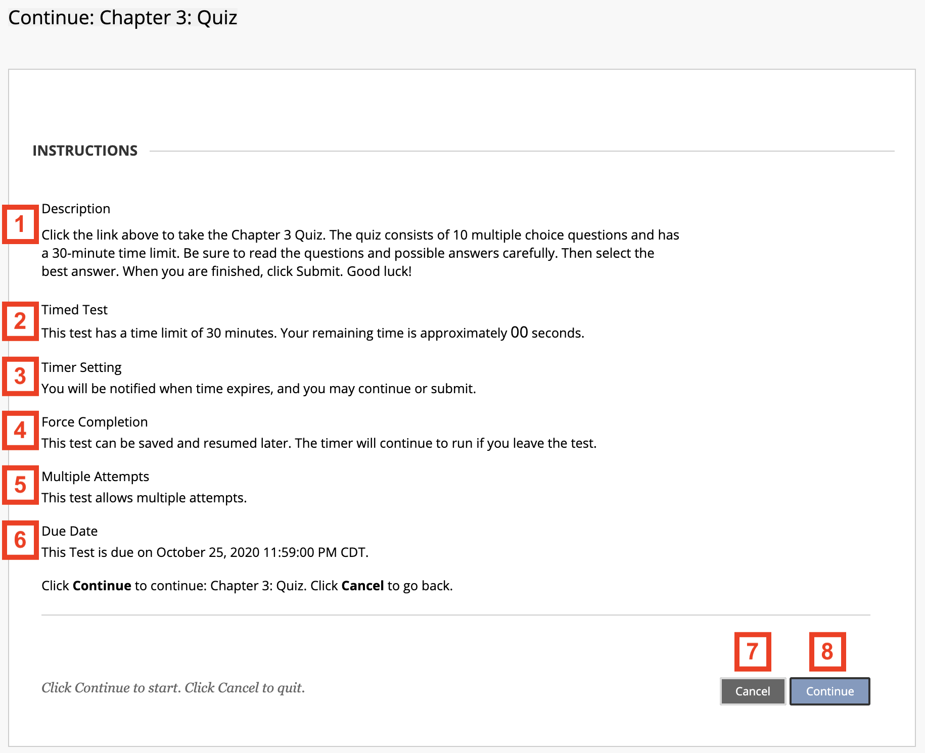

The table that follows lists each item in order and what information displays in that section, if applicable. If you do not see one of the sections explained in the table, your instructor has not enabled it.
Order | Item | Information
1 | Description | If made available by the instructor, the description of the test will be listed here.
2 | Timed Test | If the test is timed, the amount of time you have to complete it will be listed here.
3 | Timer Setting | When the timer is on, this section explains what happens if the time expires while you are working. Your instructor may allow you to continue working or have the exam automatically stop and submit your answers up to that point.
4 | Force Completion | If force completion is enabled, you must complete the assessment the first time you launch it. If you exit or lose your connection, the exam will automatically submit your answers up to that point.  If force completion is not enabled, you will see instructions in this section telling you that you may exit the assessment and continue working on it at a later time. If a timer is set and you leave the exam while the timer is running, you must resume and submit before the time expires.
5 | Multiple Attempts | This section tells you the number of times you can take the assessment. If multiple attempts is not listed, you only have one opportunity to take the assessment. If the assessment can only be taken once, after you submit your exam, you will not be able to retake it or change your answers.
6 | Due Date | This section lists the due date and time of the assessment. You must finish the exam before this date and time.
7 | Cancel button | If you clicked the title of the assessment by accident, click Cancel. Do not click the Back button on your web browser.
8 | Begin button | Click Begin to launch the assessment and begin the timer, if applicable.

After clicking Begin, you will be in the assessment.

Most of the information from the previous page will display at the top of the assessment once you have entered it. The following table lists some other important items to notice before you begin entering or selecting answers.

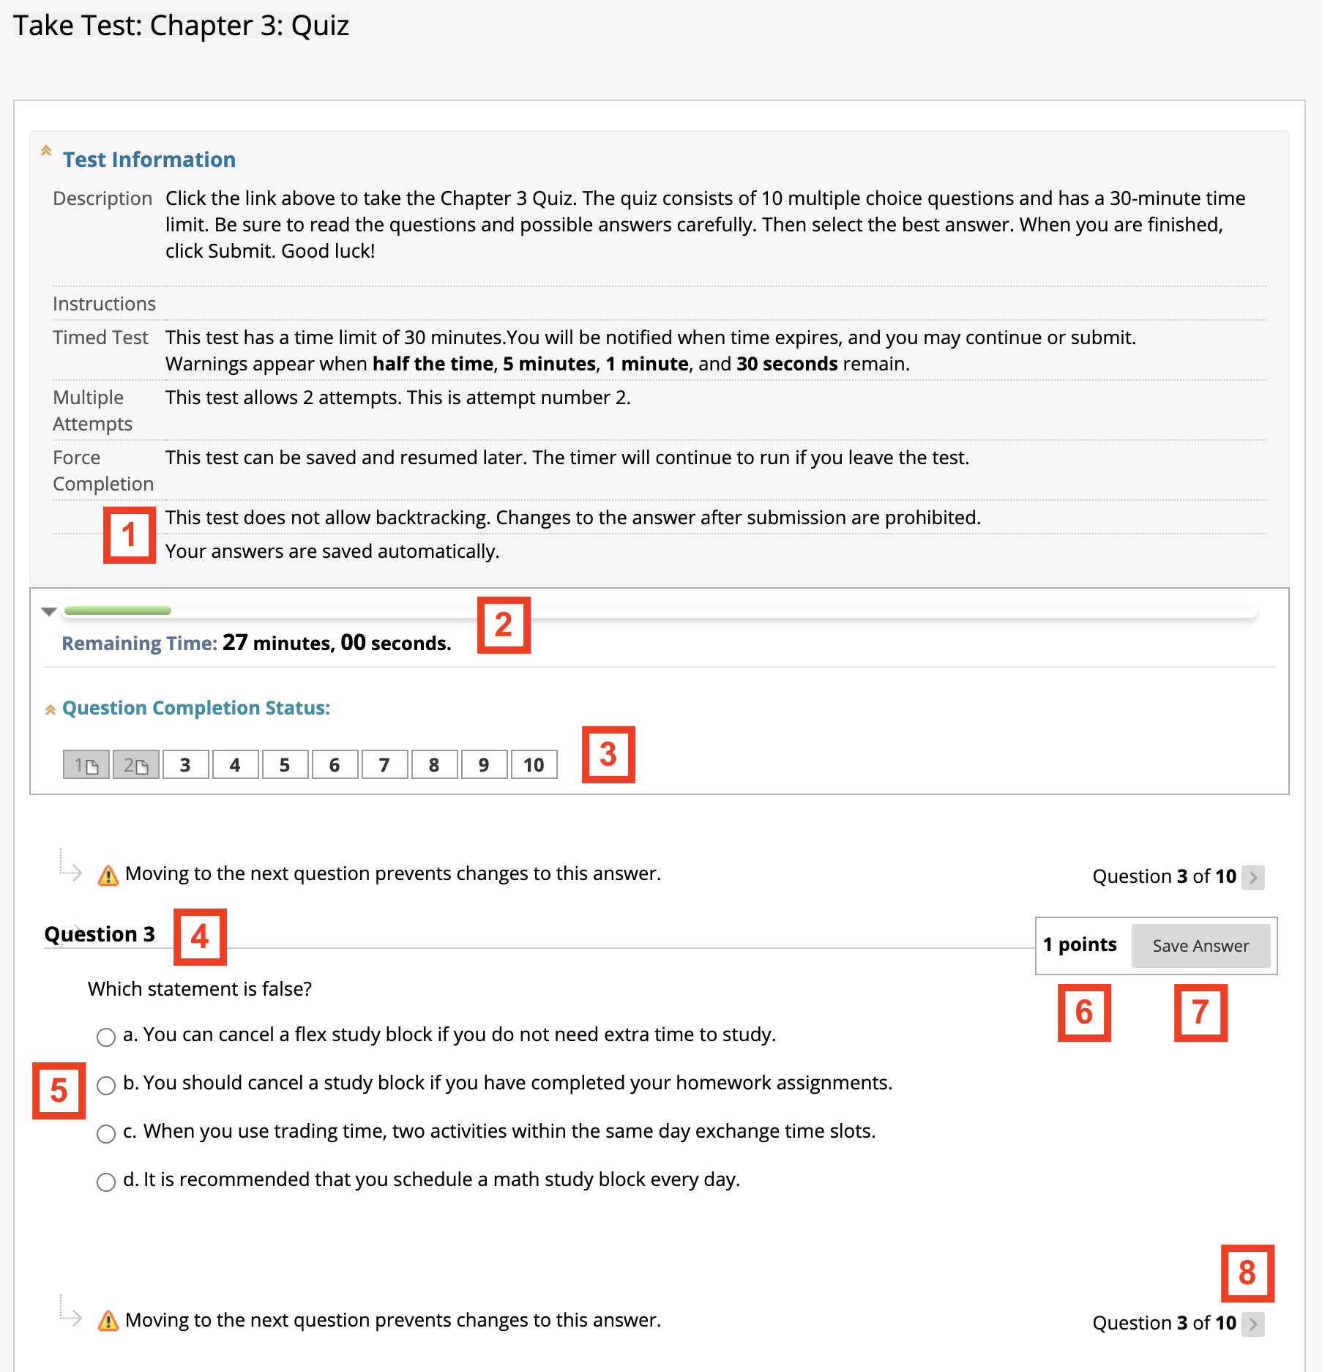

The table below provides information for items displayed while taking an assessment.
Order | Item | Information
1 | Backtracking | If backtracking prohibited is displayed, it means questions will be displayed one at a time and you will not be able to return to or change answers to questions you have already completed.
2 | Remaining Time | When the timer is on, the time remaining displays here so you know how much time you have left to complete the assessment.
3 | Question Completion Status | By clicking the double-down arrow, you can view your progress through the questions.
4 | Question Number | The question you are working on is displayed here. You may also see all of the assessment’s questions at once. This is dependent upon your instructor’s discretion.
5 | Question | This section displays the question and possible answers, when applicable. Place your answer here. If it is an essay question, type your response in the text box provided.
6 | Point Value | The number of points the questions is worth is provided on the same line as the question number.
7 | Save Answer | Before continuing to the next question, save your answer. This is especially important if your connection times out or you exit and wish to resume the exam later, if enabled.
8 | Next Question | Click the arrow button to proceed to the next question.

Additionally, on timed assessments, you will receive a drop-down warning box notifying you of the remaining time throughout your exam. Notifications will appear in the time remaining area at the following times: half the time remaining, 5 minutes remaining, 1 minute remaining, and 30 seconds remaining.

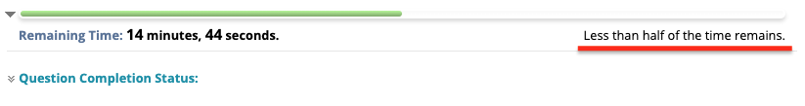

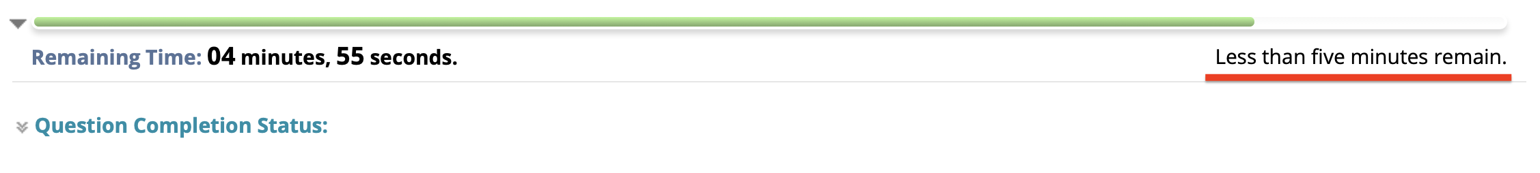

When one minute remains on the timer, the time line changes to yellow.

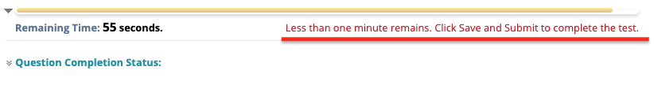

When 30 seconds remain on the timer, the time line changes to red. Plan to finish immediately and submit your exam.

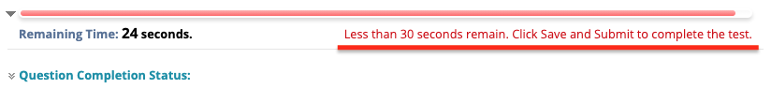

When you are finished taking your exam and answered the last question, click the Save and Submit button to submit the exam. You will receive a pop-up confirmation. Press OK.

You will then receive a submission receipt. If your instructor has released feedback, you will be able to see it by clicking OK on the bottom of the submission receipt page.

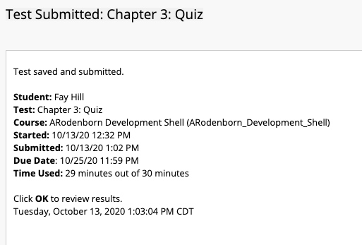

When your assessment is graded, your score and any comments from your instructor will appear in My Grades.

If feedback has been released, you can view it by clicking on your score under calculated grade.

